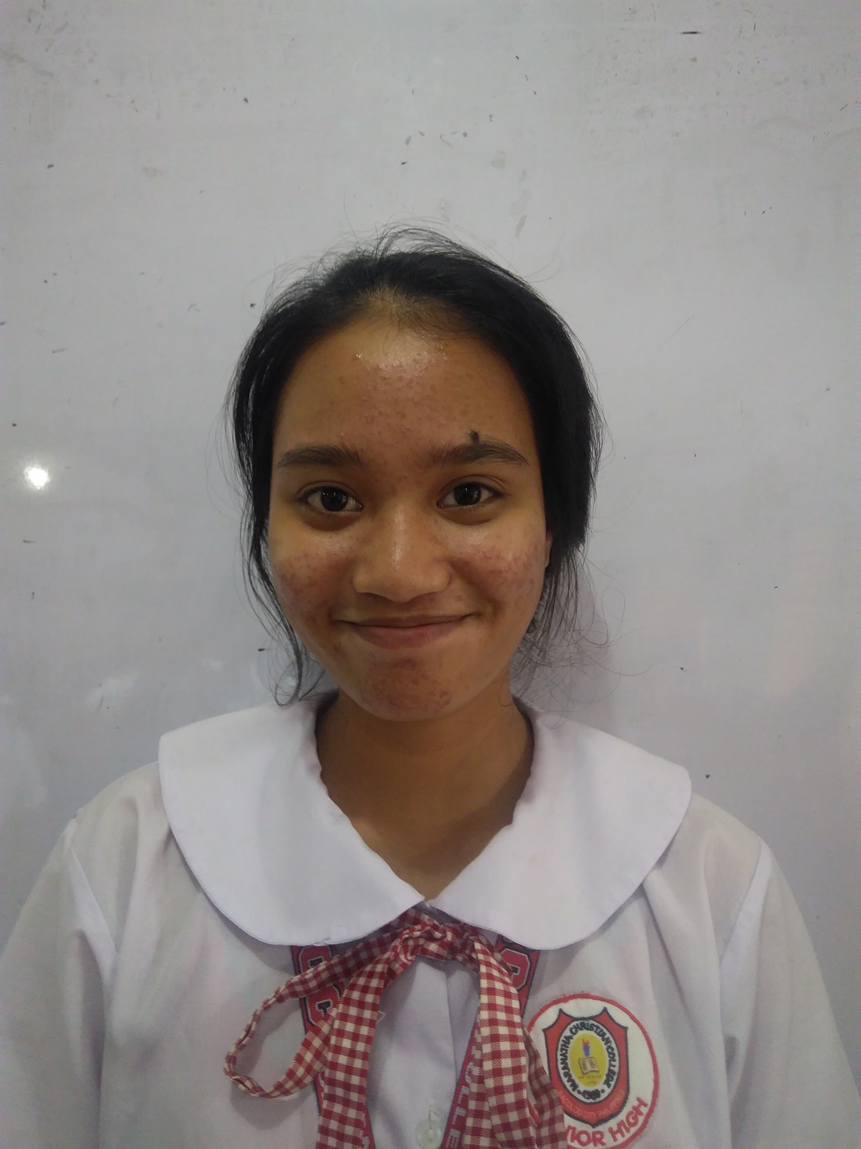

YOUR 1x1 PHOTO HERE

Hanna Jean M. Carpio
Blk.14, Lot 1, Villa Soledad subd. brgy. Estefania Bacolod city.
Mobile 09270077053
Email: hjmcarpio@maranatha.edu.ph

Objectives
To be able to prepare food in a manner in which is presentable and satisfying for the guests cravings.
Summary
Sous Chef

Educational Background
Patricia Homes Elementary School
Maranatha Christian College

Bachelor of science in Culinary arts
VMA Global College inc.
S.Y. 2020-2024

Awards
Music award
Arts award
Chaplain’s award
4th placer Photojournalism

Organizations
*Science club
VMA Global College inc.
Member 2020-2024

*Journalism club
VMA Global College inc.
President 2020-2024

*Chess club
VMA Global College inc.
Member 2020-2024

*Music club
VMA Global College inc.
Member 2020-2024

*Glee club
VMA Global College inc.
Member 2020-2024

Skills
*Skilled in the art of cooking
*Completely versed in the techniques regarding the preparation of food.
Work Experience
Vikings Luxury Buffet
Rizal St. Bacolod,1600 Negros Occidental
(034) 431 3888

Position Sous Chef
Duties
Works alongside head chef to manage daily kitchen activities, including overseeing staff, aiding with menu preparation, ensuring food quality and freshness, and monitoring ordering and stocking.
Work Timeline January 2025 to 2028

References
Available upon request

